Урок английского языка №41-42
Тема: How to answer the phone(rules). Business letter .Неофициальное время. Лексика по теме « The UK» Работа с лексикой. Суффиксы и приставки
Цели:
- Develop Ss` skills in speaking, reading, listening on the theme
- Revise the learnt material
- Teaching culture and tolerance
Учебный материал: Неофициальное время. Лексика по теме « The UK» Работа с лексикой. Суффиксы и приставки
Упражнения на прошедшие времена /повторение, сравнение/.
Оснащение урока: интерактивная доска, опорные схемы, таблица неправильных глаголов, презентации по теме урока
Ход урока
I Организация класса
How do you feel at the beginning of our lesson?
I am so-so (fine, not bad etc.)
II Фонетическая зарядка
Неофициальное время
III Речевая зарядка
How to answer the phone(rules). Business letter
Telephone Etiquette
Nice to meet you-приятно познакомиться Pleased to meet you -приятно познакомиться.
Glad to see you-рад видеть вас.
How are you?-Как дела?
How are you doing? -Как дела? I`m fine, thanks (I am fine, good, very good, well, very well, all right, OK, so-so, not bad)
How are you feeling? -Как дела?
How are you getting on? - Как дела?
See you (later, on Sunday, sometime, in 2 days).- Увидимся(позже,в воскресенье,когда-нибудь, через 2 дня) As for me -…Что касается меня…
Call me - позвони мне
Call me back. –Перезвони мне
Wait a minute (a little, a second)- подождите минуту(немного, секунду)
Speaking. –говорите(слушаю)
This is Mr. Brown speaking Hold on, please - держитесь на связи( не вешайте трубку).
Sorry, you have the wrong number. Извините, вы набрали неправильный номер.
I am sorry, I have the wrong number. Извините, я набрал неправильный номер.
What`s up? - Nothing serious. – Что случилось?-Ничего серьёзного.
What is it? – I am ill. (sick) -Что случилось?-Я болен
What happened?- Let`s find out the situation. -Что случилось?- Давайте выясним ситуацию.
As far as I know…- Насколько я знаю...
Have a good day (trip, time)! - Приятно провести день(путешествие, время)
All the best!- Всего наилучшего!
Good luck! The same to you - Удачи! И вам тоже.
Take care! - Берегите себя!
I promise to call you.- Я обещаю позвонить тебе.
Business letter
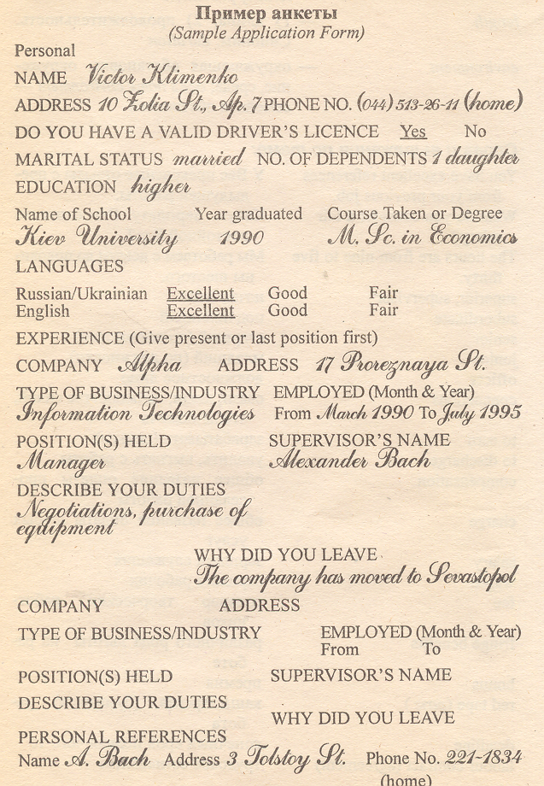
Learning new words:
The United Kingdom of Great Britain and Northern Ireland
is situated(located)
isle
island
is washed by
is bounded by (boarders)
area
consists of
population
capital
The UK
The UK is situated(located) to the west from the continent of Europe on the British Isles.
The UK is washed by the Atlantic Ocean, the North Sea and the English Channel.
The UK is bounded by (boarders) Ireland.
The UK consists of 4 parts: England, Scotland, Wales and Northern Ireland.
The area of the country is 244,100 square km.
The population of the UK is 58 million people
The biggest cities are London, Edinburg, Manchester, Liverpool and Glasgow.
The capital of the country is London.
There are no high mountains in the country
The longest rivers are the Thames, the Snowdon and the Severn.
IV Работа на интерактивной доске

1Past Simple ( Indefinite) Tense(прошедшее простое)
(yesterday, the day before yesterday, last Sunday, in 1967, 4 years ago)
I spoke to my friend. She watched TV
Did you speak to your friend? Did she watch TV?
I didn’t speak to my friend. She didn’t watch TV.

He was in the park. They were in the park.
Was he in the club? Were they at school?
He was not at school. They were not at home

2 Past Progressive( Continuous) Tense- прошедшее длительное время
(at 5 o’ clock yesterday, from….up to.. , while)
He was speaking. They were speaking.
Was he speaking? Were they speaking?
He wasn’t speaking. They weren’t speaking

3 Past Perfect
(before, after, when, by 5 o` clock….)
I had spoken to Alice.
Had I spoken to Alice?
I hadn’t spoken to Alice.
4 Past Perfect Progressive( Cоntinuous) (прошедшее длительное время)
( when, for, since)
I had been speaking to her.

Had you been speaking to her?
I hadn’t been speaking to her.

V 1 Работа над текстом
THIS IS LONDON
London is the biggest city in Great Britain. More than seven million people live and work there. London is one of the most important cities in the world. It is a centre for business and for tourism.
In London you can find some of the best theatres, cinemas and museums. There are many beautiful old churches in London. There are about 10 thousand streets in London. Most of the streets are not very wide. You can see many shops in London. Oxford Street is London’s main shopping centre. You can buy clothes, shoes and other things in it. People from all over the world shop in Oxford Street. You can find many old and new beautiful parks in the city. The largest park in London is Hyde Park. It is one of the most popular places of Londoners on hot summer days. There are many other pleasant parks and green squares there too.
2 Video on the theme and discussion
VII Физминутка для глаз
VIII Grammar
1Reviewing
Suffixes
Noun
-ation decoration
-ion decision
-ness happiness
-ity speciality
-ence difference
-ment treatment
-er (or) - reader, operator
-hood - brotherhood, neighbourhood
-ship- friendship, relationship

Adjectives
-ous dangerous
-y happy, windy
-tific scientific
-ly cowardly - ful beautiful
-less homeless, hopeless
-ial social
-ly friendly
-ful harmful
-ent different
Adverb
-ly friendly
High (highly) late early long much
Verb
- en strengthen
- ize -specialize
2 The group work IX Групповая работа
Prefixes
In- dis(против)
Inactive
Inattentive dislike
Invisible dishonest
Independent disadvantage
Indirect
Incorrect
indefinite
Im- re- (снова)
Impolite rewrite
Imperfect redo
Immodest recopy
Impossible replay
Un- mis- ( неправ)
unhealthy misunderstand
untrue misaddress
uncertain misfortune
undress
unwise
unpopular
unkind
unattractive
unhappy
unknown
uneasy
unimportant
unfinished
uncomfortable
unfriendly
il-
illogic
illegal
Ir-
Irregular
Irresponsible
Non- living
XI Презентации на интерактивной доске
Presentations on the theme
XII Итоги урока, оценки, домашнее задание
How do you feel now?
I am good (fine, O.K. etc.)
ХIII Краткий анализ урока

