**Урок английского языка №41-42**

**Тема: Relationships.** New vocabulary. Работа с текстом.

**1 Learn new meanings (изучите новые понятия)**

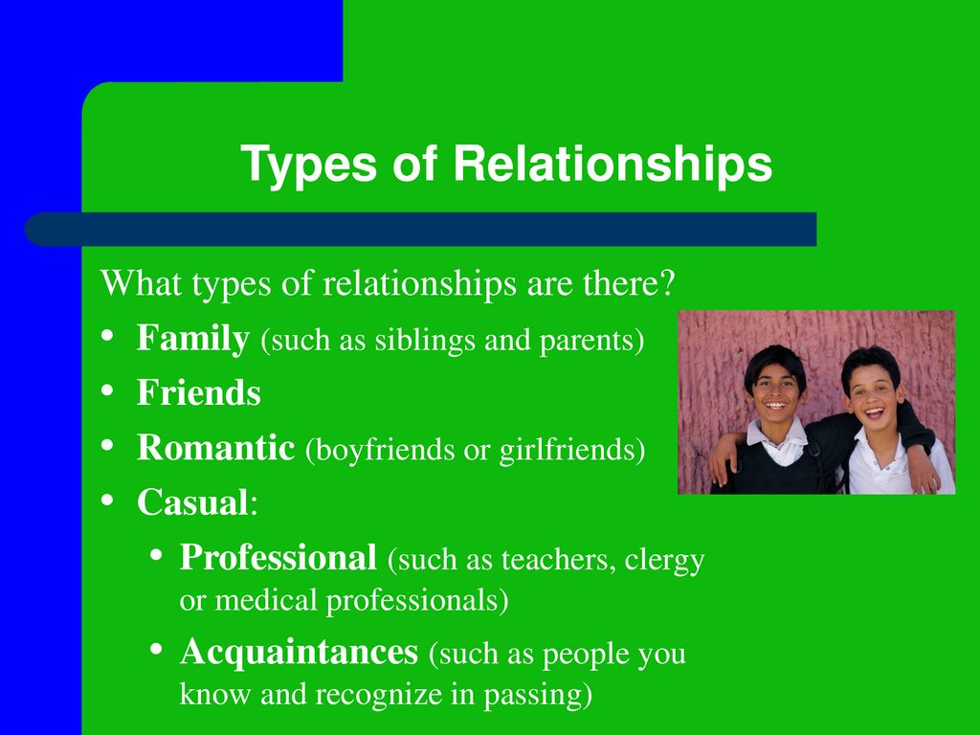

**2 Read the text below and answer the questions:**

Every day we meet new people and every time we take out something important for ourselves. Any person isn’t met by us in vain. Building the relationships is always a hard work as well as their further development. They demand active participation of all involved parties. Sincerity, reciprocity and respect are those bases without which any relationships will fail. It is necessary to be able to forgive. Many people consider the forgiveness as a sign of weakness. But words “I forgive you” do not mean that at all. They mean more – “I won’t allow the past to spoil the future and the present therefore I forgive you and I release all offenses”.

1 All people isn’t met by us in vain, isn’t it?

2 Why building the relationships is a hard work to us?

3 What are the bases without which any relationships will fail?

4 What many people consider about the forgiveness?

**3 Revise the vocabulary about relationships (повторите слова, относящиеся к человеческим отношениям)**

1. adopted child — усыновленный ребенок
2. extended family — семья из нескольких поколений
3. aquaintance — знакомый
4. bosom friend — закадычный друг
5. be engaged to — быть помолвленной с….
6. break off the engagement — разорвать помолвку
7. fiancé and fiancée — жених и невеста
8. bride and groom — невеста и жених (новобрачные)
9. nice couple — приятная пара
10. single — одинокий (без пары)
11. bachelor —  холостяк
12. unmarried — неженатый
13. make a proposal – сделать предложение (о вступлении в брак)
14. marriage — брак, замужество
15. be divorced — быть в разводе
16. break up — разойтись
17. run the house — вести хозяйство
18. raise — поднимать (ставить на ноги)
19. family reunion — воссоединение семьи

