**Урок английского языка №44-45**

**Тема:** Can I help you? Can you? Вопросы. Грамматический разбор.

**1 Verb forms of questions with 'can'**

|  |  |  |
| --- | --- | --- |
| **Pronoun** | **Question** | **Positive short answer** |
| it | **Can** it speak Spanish? | Yes, it **can**. |
| we | **Can** we speak English? | Yes, we **can**. |
| you (plural) | **Can** you speak Czech? | Yes, you **can**. |
| they | **Can** they speak Dutch? | Yes, they **can**. |

**2 Do an exercise (Выполните упражнение, задайте вопросы к ответам)**

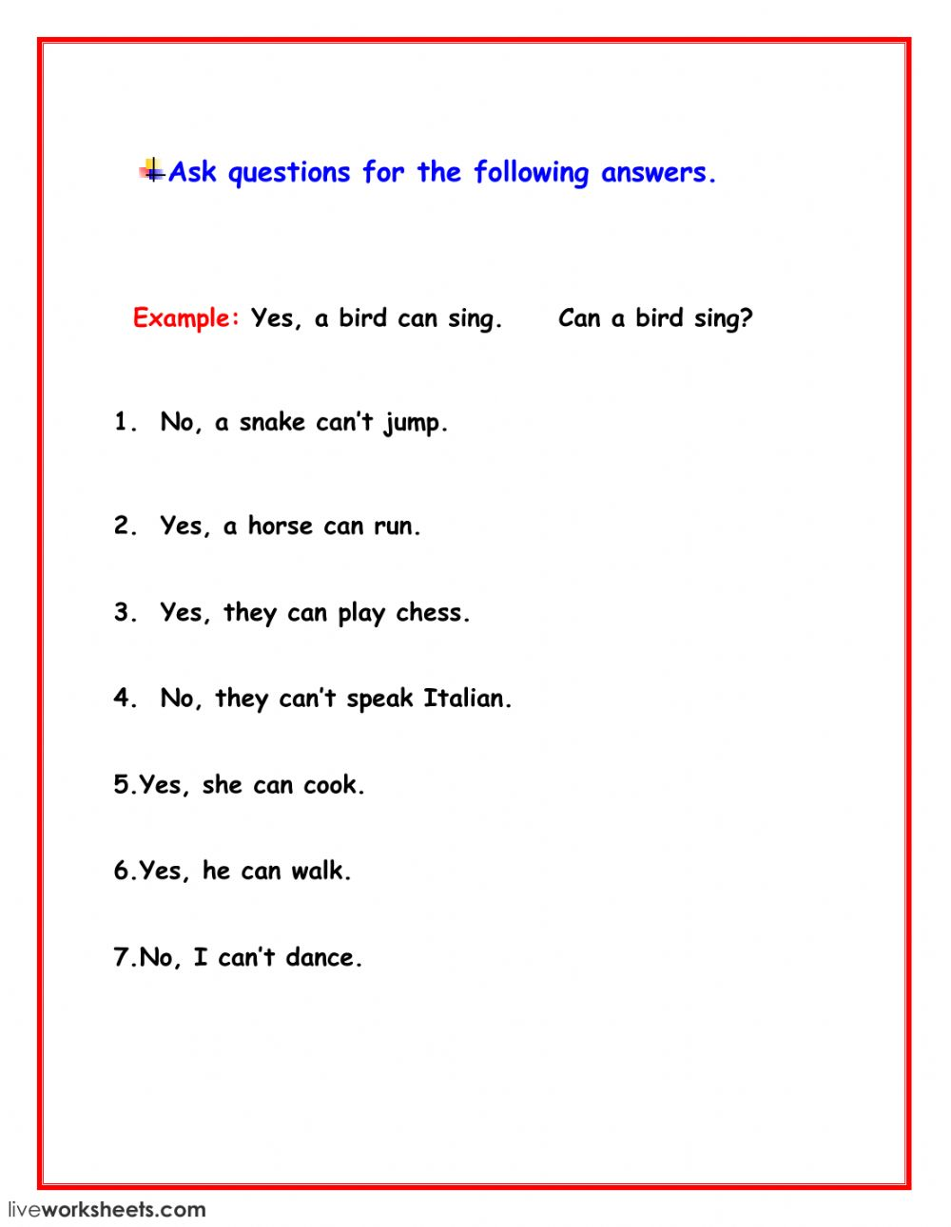

**3 Read the dialogue (прочтите диалог)**

A: Hello, Lisa.

B: Hi, Nick. How are you?

A: I'm fine, thank you. And you?

B: I'm fine too. Can you speak English?

A: Yes, I can. I go to Lingwish and I can speak English. Can you speak German?

B: No, I can't. What else can you do? A: I can swim, run and jump. And you?

B: I can't swim, but I can climb and ride a horse.

A: Wow! Ride a horse? I can't do it. Can you fly?

B: Of course, not. I can't fly. I'm not a bird. Can you drive?

A: Of course, not. I can't drive. I'm not my dad.