**Урок английского языка №44-45**

**Тема:** TV programs. New vocabulary.Чтение текста, выполнение упражнений на лексику.

**1 Read the text (прочтите текст, переведите подчеркнутые слова)**

TV programs

It is almost impossible to imagine our life without TV. It plays a great and a very important role in the life of modern man. There is practically no family that doesn't have a TV set. TV is one of the mass media kinds. Radio and newspapers tell us about different events but TV not only tells but also shows. TV has a lot of channels and everybody can watch the programs he likes. Our television suggests various programs: talk show and game show, news and sporting events, about animals and about foreign countries and so on. Soaps-lovers can watch their favorite films almost every day. TV shows us a lot of films of different countries: detective and melodrama, comedy and triller. As former I like to see adventure films, fantasy, comedies.

**2 Revise the plural form: (повторение ед.ч. и мн.ч.)**

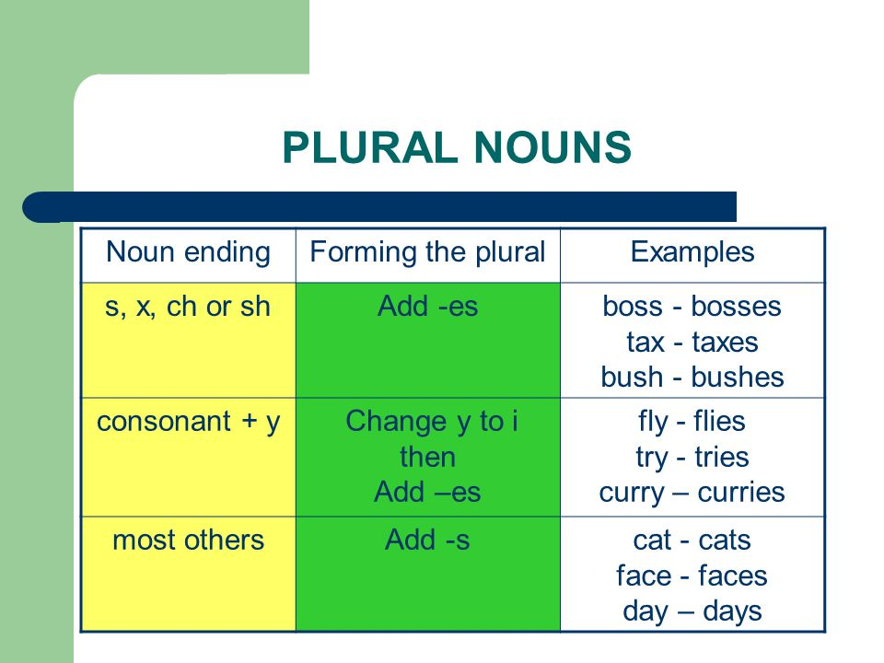

**3 Match the pictures with words (соедините картинки с названиями)**

