**Урок английского языка №28-29**

**Тема:** How to answer the phone(rules). Business letter .Неофициальное время. Лексика по теме « The UK, London» Работа с лексикой. Суффиксы и приставки

**1 Read the Telephone Etiquette ( прочтите этикет разговора по телефону)**

How to answer the phone(rules). Business letter

**Telephone Etiquette**

Nice to meet you-приятно познакомиться Pleased to meet you -приятно познакомиться.

Glad to see you-рад видеть вас.

How are you?-Как дела?

How are you doing? -Как дела? I`m fine, thanks (I am fine, good, very good, well, very well, all right, OK, so-so, not bad)

How are you feeling? -Как дела?

How are you getting on? - Как дела?

See you (later, on Sunday, sometime, in 2 days).- Увидимся(позже,в воскресенье,когда-нибудь, через 2 дня) As for me -…Что касается меня…

Call me - позвони мне

Call me back. –Перезвони мне

Wait a minute (a little, a second)- подождите минуту(немного, секунду)

Speaking. –говорите(слушаю)

This is Mr. Brown speaking Hold on, please - держитесь на связи( не вешайте трубку).

Sorry, you have the wrong number. Извините, вы набрали неправильный номер.

I am sorry, I have the wrong number. Извините, я набрал неправильный номер.

What`s up? - Nothing serious. – Что случилось?-Ничего серьёзного.

What is it? – I am ill. (sick) -Что случилось?-Я болен

What happened?- Let`s find out the situation. -Что случилось?- Давайте выясним ситуацию.

As far as I know…- Насколько я знаю...

Have a good day (trip, time)! - Приятно провести день(путешествие, время)

All the best!- Всего наилучшего!

Good luck! The same to you - Удачи! И вам тоже.

Take care! - Берегите себя!

I promise to call you.- Я обещаю позвонить тебе

**2 Business letter (составьте деловое письмо по примеру ниже)**

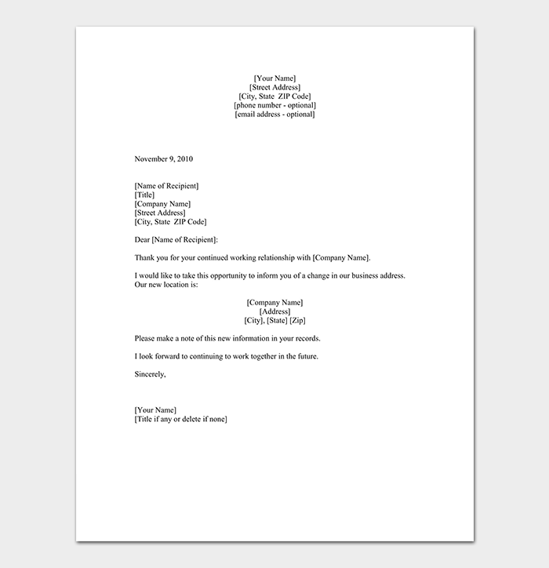

**3 Learning new words: (запишите новые слова)**

The United Kingdom of Great Britain and Northern Ireland- Соединенное королевство Великобритании и Северной Ирландии

is situated(located)- расположен

isle- остров

island- остров

is washed by- омывается ..

is bounded by (boarders)- граничит с..

area- площадь

consists of- состоит из..

population- население

capital-столица

The UK

The UK is situated(located) to the west from the continent of Europe on the British Isles.

The UK is washed by the Atlantic Ocean, the North Sea and the English Channel.

The UK is bounded by (boarders) Ireland.

The UK consists of 4 parts: England, Scotland, Wales and Northern Ireland.

The area of the country is 244,100 square km.

The population of the UK is 58 million people

The biggest cities are London, Edinburg, Manchester, Liverpool and Glasgow.

The capital of the country is London.

There are no high mountains in the country

The longest rivers are the Thames, the Snowdon and the Severn.

**4 Grammar ( изучите грамматику)**

Past Simple ( Indefinite) Tense(прошедшее простое)

(yesterday, the day before yesterday, last Sunday, in 1967, 4 years ago)

I spoke to my friend. She watched TV

Did you speak to your friend? Did she watch TV?

I didn’t speak to my friend. She didn’t watch TV.

He was in the park. They were in the park.

Was he in the club? Were they at school?

He was not at school. They were not at home

2 Past Progressive( Continuous) Tense- прошедшее длительное время

(at 5 o’ clock yesterday, from….up to.. , while)

He was speaking. They were speaking.

Was he speaking? Were they speaking?

He wasn’t speaking. They weren’t speaking

3 Past Perfect

(before, after, when, by 5 o` clock….)

I had spoken to Alice.

Had I spoken to Alice?

I hadn’t spoken to Alice.

4 Past Perfect Progressive( Cоntinuous) (прошедшее длительное время)

( when, for, since)

I had been speaking to her.

Had you been speaking to her?

I hadn’t been speaking to her.