**Урок английского языка №38-39**

**Тема:** Kind of sport. Listening the interview with sport stars. Read the text.

**1 Learn new words (выучите новые слова)**

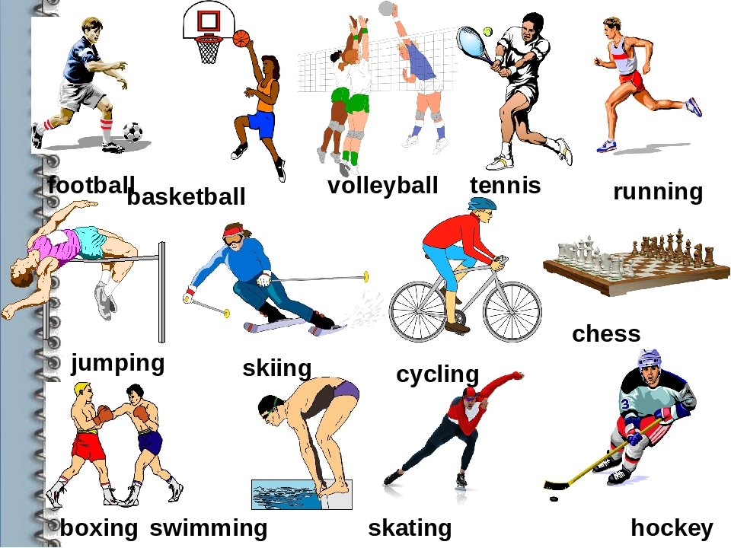

**2 Learn the rule (изучите правило)**

There are three verbs that collocate with sports and other free time activities: **go**, **do** and **play**, but they are not interchangeable:

* **Go** is used with activities and sports that end in **-ing**. The verb **go** here implies that we go somewhere to practice this sport: go swimming.
* **Do** is used with recreational activities and with individual, non-team sports or sports in which a ball is not used, like martial arts, for example: do a crossword puzzle, do athletics, do karate.
* **Play** is generally used with team sports and those sports that need a ball or similar object (puck, disc, shuttlecock...). Also, those activities in which two people or teams compete against each other: play football, play poker, play chess.

**3 Fill in the gaps (вставьте подходящие слова)**

