**Урок английского языка №38-39**

**Тема: My home is my castle.** Types of houses. Houses and Furniture. /прослушивание/. Construction “there is, there are”. Prepositions on, in, under next to Перевод тематических предложений на английский язык.

**1 Learn new words ( выучите новые слова)**

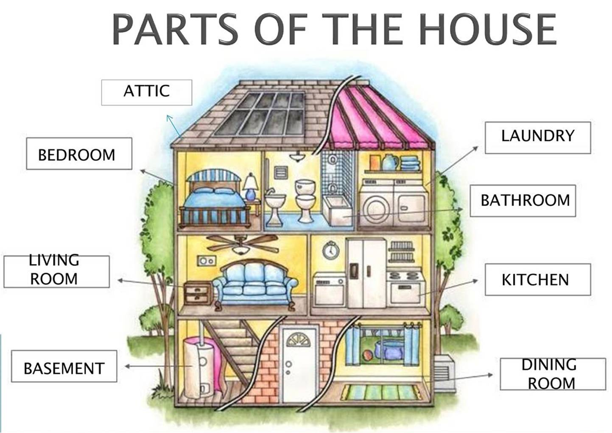

**2 Read the text «My House» . (прочтите текст «Мой дом»)**

We have 2 floors (этажи) in the house.

Upstairs (в верху) in the house there is an attic ( чердак) with a window, a balcony, and a roof(крыша). There are bedrooms, bathrooms and a study (кабинет). Downstairs( внизу) in the house there is a hall( прихожая), a kitchen, a living room and a cellar(подвал).

A hall( прихожая).

In the hall there is a rug (коврик), a cupboard (посудный шкаф), a mirror(зеркало), a table, a telephone, a light switch(выключатель) and a door. In the hall there are pictures on the wall (стена), lamps, keys(ключи), stairs(лестница) and stools(табуретки).

In the Living room.

In the room there is a carpet (ковёр), a fireplace ( камин), a rug, a sofa, a stereo, a table, a television, a mirror, a lamp and a bookcase. There are armchairs (кресла), candles (свечи), chairs, curtains(занавески), pictures, shelves( полки) and vases.

There is a sofa (диван) near the wall. There is a stereo near the fireplace. There are vases on the table and on the TV. There is a rug near the fireplace. There is a cat under the table.

In the Bedroom.

In the bedroom there is a bed, a chest of drawers(комод), a wardrobe, a closet, a table, a mirror, a stool and a rug. There are curtains, a blanket (одеяло), a sheet (простыня), pillows(подушки), combs(расчёски), brushes(массажки), a clock, a lamp and a vase.

In the Kitchen.

There is a refrigerator (fridge) (холодильник), a gas cooker (газовая плита) , a table, chairs, a cupboard, shelves(полки),a dishwasher, a stove(плита), a washing machine, a microwave oven in the kitchen.

**3 Make up sentences**:

(Составьте предложения об одной своей комнате в доме используя конструкции ниже)

Construction “there is, there are”. Prepositions on, in, under next to