**Урок английского языка №40-41**

**Тема:** Can/may/must negative forms. Выполнение грамматических упражнений. Закрепление правила.

**1 Read the rule (прочтите правило)**

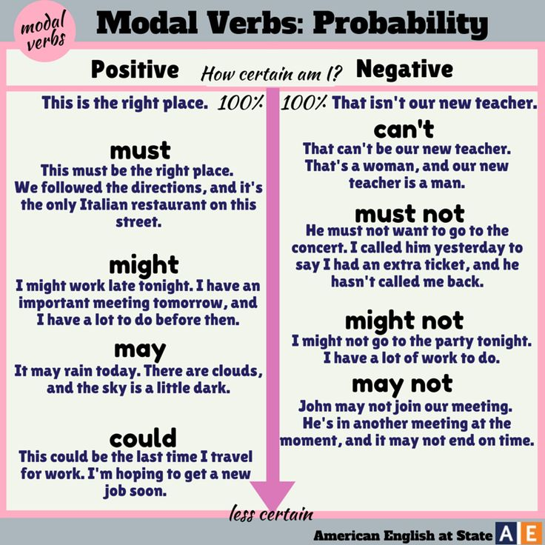

**2 Rewrite the sentences using modal verbs (перепишите предложения используя модальные глаголы)**

1. — There’s a chance that she’s in the airport.  (could)

_____________________________________________________________

2. — I knew how to ride a horse when I was six. (could)

_____________________________________________________________

3. — John isn’t sure if he is going to Turkey.  (might not)

_____________________________________________________________

4. — Do not block the emergency exit.  (mustn’t)

_____________________________________________________________

5. — It is dangerous to use mobile phones on the plane. (mustn’t)

_____________________________________________________________

6. -It’s possible that he’ll be there to meet us. (may)

_____________________________________________________________

7. — This is a surprise. Don’t tell anybody about it. (shouldn’t)

_____________________________________________________________

**3 Writing. Write down your own list that you must or musn`t to do next year.**

