**Урок английского языка №32-33**

**Тема:** The Future Simple. Affirmative form.

**1 Learn the rule.(изучите правило)**

The simple future refers to a time later than now, and expresses facts or certainty. In this case there is no 'attitude'.

**The simple future is used:**

* To predict a future event:  
  It **will rain** tomorrow.
* With I or We, to express a spontaneous decision:  
  **I'll pay** for the tickets by credit card.
* To express willingness:  
  **I'll do** the washing-up.  
  **He'll carry** your bag for you.

**Note:**In modern English **will** is preferred to **shall**. Shall is mainly used with **I** and **we** to make an offer or suggestion, or to ask for advice (see examples above). With the other persons (you, he, she, they) shall is only used in literary or poetic situations, e.g. "With rings on her fingers and bells on her toes, She ***shall have*** music wherever she goes."

* The form "it will" is not normally shortened.
* **To see: Simple future tense**

| **Affirmative** | **Negative** | **Interrogative** | **Interrogative Negative** |
| --- | --- | --- | --- |
| **I** will see | I won't see | Will I see? | Won't I see? |
| \***I** shall see |  | *Shall I see? |  |
| **You** will see | You won't see | Will you see? | Won't you see? |
| **He** will see | He won't see | Will he see? | Won't he see? |
| **We** will see | We won't see | Will we see? | Won't we see? |
| \***We** shall see |  | *Shall we see? |  |
| **They** will see | They won't see | Will they see? | Won't they see? |

2 **Create a topic about job of your dream.( Составьте эссе о работе своей мечты, с помощью вопросов.**

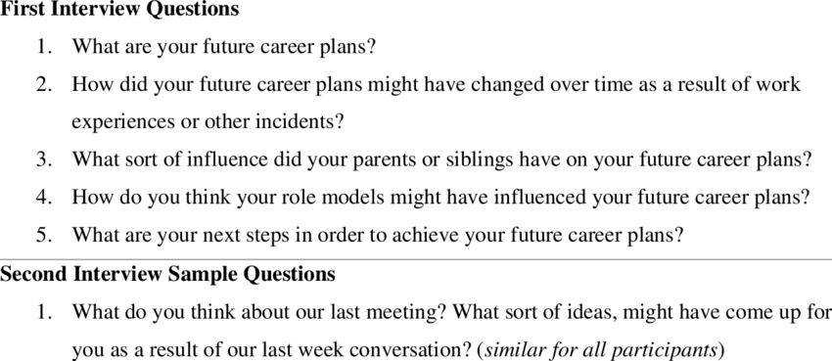

**3 Do an exercise.(С1 по 10 предложение, вставьте глагол и переведите предложения )**

