**Урок английского языка №36-37**

Тема: Buying the food . Adverbs of frequency.

Prices. Shopping. Чтение текста. Закрепление темы.

**1 Read the text “Shopping” (прочтите текст о покупках)**

There are many kinds of shops in every town or city, but most of them have a food supermarket, a department store.

I like to do my shopping at big department stores and supermarkets. They sell various goods : sausages, fish, sugar, macaroni, flour, cereals, tea meat and poultry, brown and white bread, rolls, biscuits.

A department store is composed of many departments: clothes, shoes, sports goods, toys, china and glass, , cosmetics, cameras, records and other things. You can buy everything you like there.

I like to go shopping but not often. I prefer doing shopping with my mother when we buy clothes and presents.

**2 Learn the rule Adverbs of frequency (прочтите правило о наречиях)**

**Adverbs of frequency** tell us how often something is done. **Adverbs of frequency** include; always, constantly, continually, frequently, infrequently, intermittently, normally, occasionally, often, periodically, rarely, regularly, seldom, sometimes etc.

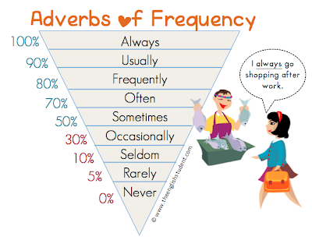

**3 Prices. Revising big numbers. ( запомните большие цифры )**

100- one hundred

200- two hundred

1000-thousand

2000-two thousand

2550- two thousand five hundred fifty

100 000- one hundred thousands

1 000 000- million

Euro- евро

Dollar-доллар

Tenge-тенге

Rouble-рубль

Coin-копейка

**4 Write down how many costs thing what you want to have.**

Example:

I want to have a car that costs five million five hundred tenge.