**Урок английского языка №35-36**

Тема: Buying the food . New vocabulary.

Prices. Shopping. Чтение текста. Закрепление темы.

**1 Read the text (прочтите текст)**

**Shopping**

Shopping is a part of our daily life. And we go shopping whether we like it or not. There are people who like or dislike going shopping. So they make a list of what they need and buy the needed things. Sometimes some buyers even don't care about the price. But there are people who go form store to store looking for goods of better quality and lower price. But there is a very good service called Internet Market. It really helps you to save your time and get goods of high quality. You look through a catalogue, choose the things you like, order them There are many kinds of shops in every town or city, but most of them have a food supermarket, a department store.

I like to do my shopping at big department stores and supermarkets. They sell various goods : sausages, fish, sugar, macaroni, flour, cereals, tea meat and poultry, brown and white bread, rolls, biscuits.

A department store is composed of many departments: clothes, shoes, sports goods, toys, china and glass, , cosmetics, cameras, records and other things. You can buy everything you like there.

I like to go shopping but not often. I prefer doing shopping with my mother when we buy clothes and presents.

**2 Prices. ( изучите название цен)**

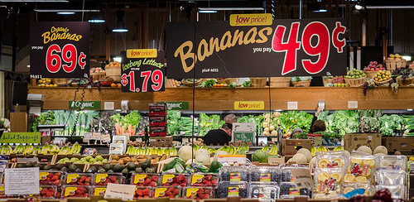

Remember that in English, we divide prices at the decimal point.

For example:

$4.59

four dollars (and) fifty-nine cents

four / fifty nine

(long way)

(short way)

(Time is also divided in a similar way: 12:47 is said "twelve / forty-seven")

Americans often say large numbers in "phrases" of two digits.

For example:

267

4381

two hundred sixty-seven

two / sixty seven

four thousand three hundred eighty-one

forty-three / eighty-one

(long way)

(short way)

Practice the following prices (both long and short ways) with a partner:

That will be____(price)______

That comes to ____(price)____

$59.65

$27.95

$14.40

$1.79*

$6.75

$77.17

$29.00**

$82.03

$70.50

$425.78

$781.34

$211.54

$231.49

$690.42

$380.18

$3,657.88

$9,405.31

$1,550.15

*Also: a dollar seventy-nine

**Also: twenty-nine (dollars) even

**3 Do your own Shopping List with prices. ( Составьте список покупок с ценами)**