Урок английского языка №31-32
Тема: Conclusion. Websites. Internet in our life. Our technological future. Видео. Работа с текстом: «Internet in our life». Прослушивание диалогов, заполнение таблиц. Закрепление материала .Тесты.
Цели:

- Develop Ss` skills in speaking, reading, listening on the theme
- Revise the learnt material
- Teaching culture and tolerance
Учебный материал: Видео. Работа с текстом: «Internet in our life». Прослушивание диалогов, заполнение таблиц. Закрепление материала
Упражнения на настоящие времена /повторение, сравнение/.
Оснащение урока: интерактивная доска, опорные схемы, таблица неправильных глаголов, презентации по теме урока

Ход урока
I Организация класса
How do you feel at the beginning of our lesson?
I am so-so (fine, not bad etc.)
II Фонетическая зарядка
пословицы:
A good (beginning) makes a good ending – Хорошее начало – хороший конец
16 A sound mind in a sound body – В здоровом теле здоровый дух

III Речевая зарядка


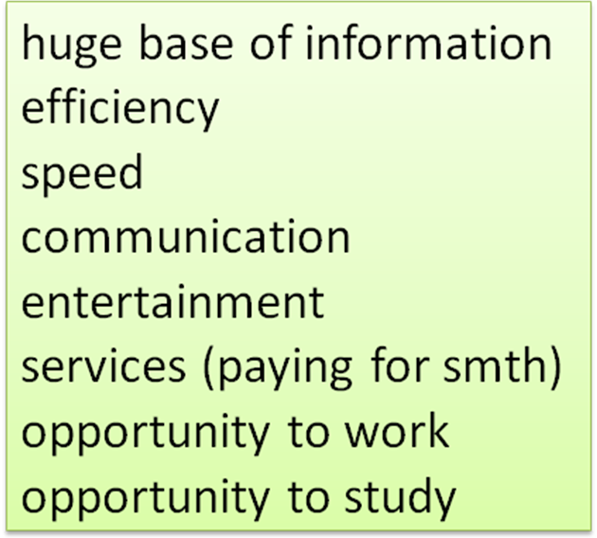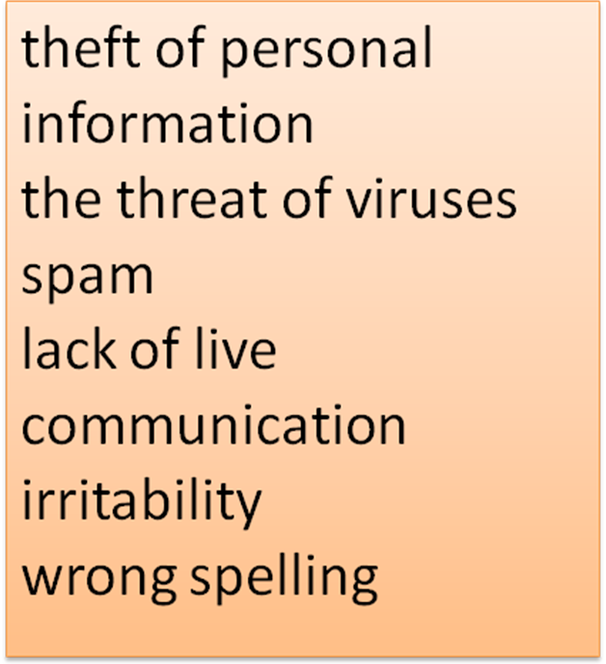
What | do | you | read | magazines
Where |  | your friends | watch | on TV
When |  | the children | speak | over the telephone
Why |  | they | write | reports
Whom |  |  | travel | to Europe
Which pictures | does | she | think | about my idea
How |  | Pete | help | your parents
How many |  | mum | spend | on books
How much |  | Ann | pay | for food
How long |  | he | make | a report
Whose |  |  | ask | a question
 |  |  | wait for | your mum
 |  |  | call | our friend

IV Работа на интерактивной доске

Видео и работа над вопросами

V Работа над текстом
Internet
It’s hard to imagine our lives without Internet nowadays. It has become an important part of every person’s life. The Internet is very helpful, because it's a huge database of knowledge. One of the obvious advantages of Internet is its efficiency. You can find the information you’re looking for in 5 seconds. But there are other negative aspects of Internet use. Since the time of Internet appearance, many other media sources became unnecessary. People have stopped reading paper books and newspapers. That’s because all books or prints can be found online, as well as all films and programs. Most people write with mistakes, because the Internet automatically corrects mistakes and people do not care about the rules of writing. Other problem is the lack of live communication. People get used to communicate virtually and do not know how to behave in real life when meeting. Internet is addictive, people become irritable. For example parents ask you to distract from the Internet and throw out the garbage, you start to get angry. If distract you while using the internet or in the process of playing on the computer you react sharply, it's bad for the nervous system. The conclusion is: technology needed to survive and prosper in today's world, however, it is necessary to control the time spent at the internet.

VII Физминутка для глаз
VIII Grammar
Present Tenses(настоящие времена)

1Present Simple(Indefinite) (настоящее, простое)
(usually, often, sometimes, always, every day, regularly, once, twice, 3 times a week)
I speak English. He speaks English
Do you study English? Does he speak English? I don’t study English. He doesn’t speak English.
2 Present Progressive (Continious) (настоящее длительное)
(now, right now, at the moment)
He is speaking to John.
Is he speaking to John?
He is not speaking to John.
3 Present Perfect (настоящее совершённое)
(just, already, ?ever, -never, -?yet, recently, for, since, this day, this week, this month)
I have spoken to mum. He has talked to Tom.
Have you spoken to mum? Has he talked to Tom?
I have not spoken to mum. He has not talked to Tom
4 Present Perfect Progressive (настоящее совершенное длительное)
(for, since, how long)
I have been speaking to him. She has been speaking to Pete.
Have you been speaking to him? Has she been speaking to Pete?
I have not been speaking to him. She hasn’t been speaking to Pete.

Special questions
1Reviewing 2 The group work IX Групповая работа
XI Презентации на интерактивной доске
Лексика по теме: «Business companies»
Company development
Firm subsidiary company
Corporation branch
Association meeting of Shareholders
Production board of Directors
Sales correspondence
Export business proposal
Financial contact
Turnover Draft of Contract
Research join
Presentations on the theme
XII Test (Present Tenses)
XIII Итоги урока, оценки, домашнее задание
How do you feel now?
I am good (fine, O.K. etc.)
ХIV Краткий анализ урока

